 | EUROPEAN COMMISSION  DIRECTORATE-GENERAL  INFORMATICS  Information Systems Directorate

European Commission
CIPADMIN Use Case Specification:
UC0050 - eTrustEx Admin Console - Manage Roles

Date: | 18/01/201716/09/2014
Version: | 21.000000
Authors: | Anamaria BATRINU
Revised by: | Sandro D'Orazio, Maarten Daniels
Approved by:
Public:
Reference Number:
TABLE OF CONTENTS
1. Use-Case Description 5
1.1. Primary Actor 5
1.2. Definitions, Acronyms and Abbreviations 6
1.3. References 6
1.4. Context Diagram 7
1.4.1. CIPA Administration Console 7
1.4.2. Manage Role module 8
2. Creation - Flow of events 8
2.1. Basic creation flow 8
2.1.1. User selects the Create Role menu action 8
2.1.2. The System displays the "Role" page 8
2.1.3. User enters information 9
2.1.4. The System creates the Role 9
2.1.5. User acknowledges the creation 10
2.1.6. The System redisplays the 'Role' page 10
2.1.7. The basic creation flow ends. 10
2.2. Basic Visualization Flow 10
2.3. Basic Modification Flow 11
2.3.1. After step 2.1.2., User chooses modify option on the role line 11
2.3.2. System brings role in edit mode 11
2.3.3. User modifies one or more fields 11
2.3.4. User chooses "Save" option on the role line 12
2.3.5. System verifies the business rules and saves the role 12
2.3.6. Basic modification flow ends. 12
2.4. Basic Deletion Flow 12
2.4.1. After step 2.1.2., User chooses delete option on the role line 12
2.4.2. System asks for confirmation 12
2.4.3. User confirms deletion 12
2.4.4. System verifies the business rules and deletes the role 12
2.4.5. Basic deletion flow ends. 12
2.5. Alternative Flows 12
2.5.1. A1: at step 2.1.4, Business Rules are not verified 12
2.6. Exceptional Flows 13
2.6.1. E1: at step 2.1.1, 2.2, 2.3.1 and 2.4.1 user is not authorized for the operation 13
2.6.2. E2: at step 2.4.4, business rules not verified 13
3. Special Requirements 13
3.1. Interface(s) with other Systems 13
3.2. Security Requirements 13
3.3. Other Special Requirement 13
4. Preconditions 13
5. Post conditions 13
6. Additional Information 13
6.1. Includes 13
6.2. Extends 13
7. Mock-up Pages 14
7.1. "Role" page 14

Document History

Version | Date | Comment | Modified Pages
0.001 | 20/09/2013 | First draft | All
0.002 | 10/04/2014 | Updated mockup screen | 8.1. "Role" page
0.003 | 24/04/2014 | Added 'Is Technical Flag' | 8, 9, 10, 13
0.004 | 10/06/2014 | Updated business rules | Sections 2.1 and 2.3
0.005 | 25/06/2014 | Introducing bidirectional flag | Sections 2.1, 2.3 and 7.1
0.006 | 25/08/2014 | Bidirectional flag rule | Section 2.3
0.007 | 17/09/2014 | Added UC50_BR11
0.008 | 14/10/2014 | Maximum field length has been changed from 250 to 255 characters.
0.009 | 15/10/2014 | Removed specific messages (quoted ones) to allow more flexibility.
1.000 | 04/11/2014 | - CIPADMIN-243 (mockup labels)  - CIPADMIN-279 (logging) | - Section 7  - where needed
1.001 | 11/12/2014 | CIPADMIN-267: Support user role  Diagrams update
1.002 | 26/01/2015 | CIPADMIN-264: Ordered lists | Section 2.1.2
1.003 | 26/10/2016 | ETRUSTEX-1392
2.000 | 18//01/2017 | ETRUSTEX-1937: Reorganizing CIPAdmin user roles

Use-Case Description
This use case depicts the sequence of actions that a user needs in order to create a Role. The document also describes of the managing operations for an existing Role (search, view, edit or delete). A Role is included in each Profile and contains the information about the job function or title which is associated with expected behaviour or responsabilities of a party.
The "Role Management" service is exposed on the CIPAdmin module of e-TrustEx System.
In the remainder of the document the CIPADMIN application will be referred to as the System.

Primary Actor
A humain user can access the Manage Role feature via CIPAdmin interface. For detailed user access rights on each feature option, please see UC 0100 - eTrustEx Admin Console - Authenticate and Authorise User, section 6.3 User Access Rights.
In the remainder of the document, the user will be reffered to as User or by his/her role, in those cases where role specific rules apply.

Definitions, Acronyms and Abbreviations
Acronym, Abbreviation or Definition | Explanation
CIPA | Common Infrastructure for Public Administrations
CIPADMIN | CIPA AdminConsole
ADM | A user having General Administrator role. The General Administrator is the Administrator of the CIPAdmin application.
CBO | A user having Central Business Owner role. The Central Business Owner is responsible for the organization and operation of a business domain and uses CIPA in his business context.
UC(s) | Use Case(s)

References
Ref. | Reference | Title / description | Version | Date
[R1] | CIPADMIN-VISION | CIPADMIN Vision document | V.61-EN | 18/04/2013

Context Diagram

CIPA Administration Console
The diagram below depicts all the Services available on the CIPA Administration Console for e-TrustEx platform. Depending on the user role, only a subset of those services is exposed on the e-TrustEx Administration Console home page.
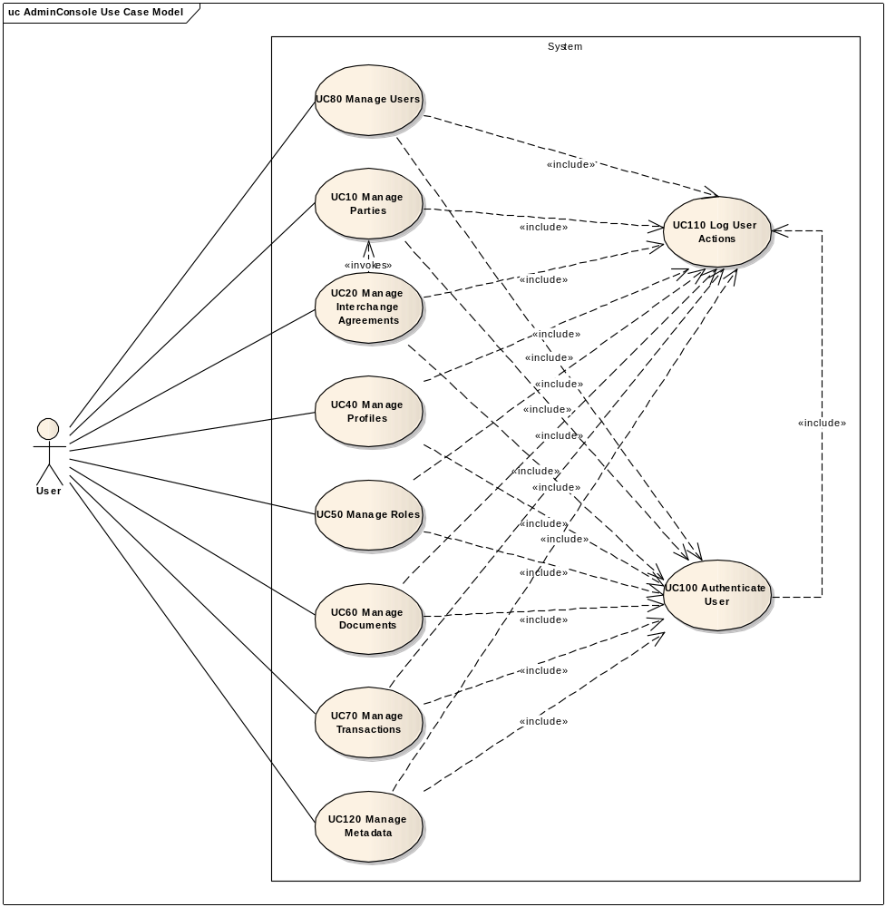

Manage Role module
The diagram below depicts how this use case interacts with other use cases implemented in the Administration Console.
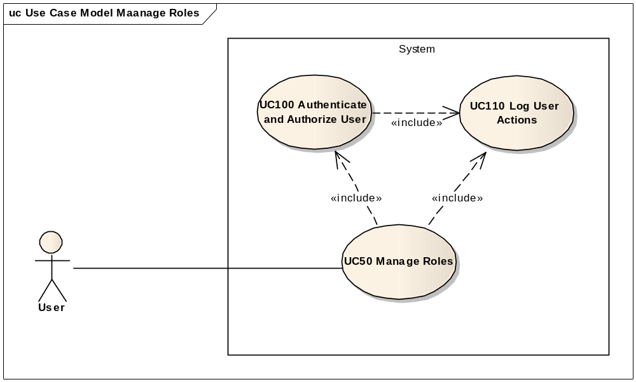

Flow of events
The conventions described in User Interface Generic Conventions document must be applied.

Basic creation flow

User selects the Create Role menu action
ID | Description
UC50_BR01 | User needs to have the correct access rights in order to access this feature. Please see UC 0100 - eTrustEx Admin Console - Authenticate and Authorise User, section 6.3 User Access Rights for more information.
User selects the Role menu of the e-TrustEx Administration Console home page.

The System displays the "Role" page
The System displays the 'Create Role' page as described in paragraph 7.1. "Role" page:
- "New Role" section:
  - Role code – mandatory
  - Role description/name – mandatory
  - Is technical role flag – optional (if not filled in, it is defaulted to false)
  - Bidirectional flag – optional (if not filled in, it is defaulted to false)
  - Cancel button for cancelling the creation
  - Save button for saving the entered information
- "Available Roles" section:
  - The system retrieves a list of all available roles and populates the roles table.
  - The roles list is ordered alphabetichaly by code in ascendant order and ignoring case

User enters information
ID | Description
UC50_BR02 | Role code is mandatory.
UC50_BR03 | Role name/description is mandatory.
UC50_BR04 | Role technical flag is optional and if not filled in, it shall be defaulted to false.
UC50_BR05 | Role bidirectional flag is optional and if not filled in, it shall be defaulted to false.

- User enters role code and description.
- User clicks 'Save' button.

The System creates the Role
ID | Description
UC50_BR02 | Role code is mandatory.  If missing, user is notified that "Role code must not be empty or spaces".
UC50_BR03 | Role name/description is mandatory.  If missing, user is notified that "Role name must not be empty or spaces".
UC50_BR04 | Role technical flag is optional and if not filled in, it shall be defaulted to false.
UC50_BR05 | Role bidirectional flag is optional and if not filled in, it shall be defaulted to false.
UC50_BR06 | Role code and role name must be at most 255 characters.
UC50_BR07 | Leading and trailing spaces must not be part of the save field nor taken into account for UC50_BR06 and UC50_BR11, for both role code and role name.
UC50_BR08 | Role code must be unique.  If not, user is notified that "A role with the specified code already exists".
UC50_BR09 | Role name must be unique.  If not, user is notified that "A role with the specified name already exists".
UC50_BR10 | User is always notified of the success of the operation: "Role successfully saved".
UC50_BR11 | Role code and role name must be at least 2 characters long.
- The System validates the page according to the business rules.
- The system saves the Role.
- System logs the successful creation: include use case Log CIPAdmin User Actions
- The System informs the user about the success of the operation

User acknowledges the creation

The System redisplays the 'Role' page
- The System reinitializes all fields on the page
- The System refreshes the role list
- The System redisplays the 'Role' page as described in paragraph paragraph 7.1. "Role" page

The basic creation flow ends.

Basic Visualization Flow
ID | Description
UC50_BR01 | User needs to have the correct access rights in order to access this feature. Please see UC 0100 - eTrustEx Admin Console - Authenticate and Authorise User, section 6.3 User Access Rights for more information.
After step 2.1.2., the user can visualize the desired role in the role list.

Basic Modification Flow
ID | Description
UC50_BR01 | User needs to have the correct access rights in order to access this feature. Please see UC 0100 - eTrustEx Admin Console - Authenticate and Authorise User,section 6.3 User Access Rights for more information.
UC50_BR12 | User cannot modify role code.
UC50_BR03 | Role name/description is mandatory.  If missing, user is notified that role name must not be empty or spaces.
UC50_BR04 | Role technical flag is optional and if not filled in, it shall be defaulted to false.
UC50_BR05 | Role bidirectional flag is optional and if not filled in, it shall be defaulted to false.
UC50_BR06 | Role code and role name must be at most 255 characters.
UC50_BR07 | Leading and trailing spaces must not be part of the save field nor taken into account for UC50_BR06 and UC50_BR11, for both role code and role name.
UC50_BR09 | Role name must be unique.  If not, user is notified that a role with the specified name already exists.
UC50_BR10 | User is always notified of the success of the operation.
UC50_BR13 | If a role is bidirectional, and used in a bidirectional interchange agreement, than the bidirectional flag shall not be swiched to NO.  Definition: Bidirectional Interchange Agreement = An interchange agreement between two parties having the same role (this role is marked as bidirectional in the database).
UC50_BR11 | Role code and role name must be at least 2 characters long.

After step 2.1.2., User chooses modify option on the role line

System brings role in edit mode
- New Role section becomes Edit Role section and contains the information of the role to modify
- Cancel button is used to cancel the modification and reload the New Role section
- Save button is used to save the modified role

User modifies one or more fields
User can modify one or more of the following fields:
- role description
- technical flag
- bidirectional flag

User chooses "Save" option on the role line

System verifies the business rules and saves the role
- System verifies business rules
- System saves role
- System logs the successful modification: include use case Log CIPAdmin User Actions
- System updates the role list
- System shows the "Role" page as described in paragraph 2.1.2

Basic modification flow ends.

Basic Deletion Flow
ID | Description
UC50_BR01 | User needs to have the correct access rights in order to access this feature. Please see UC 0100 - eTrustEx Admin Console - Authenticate and Authorise User,section 6.3 User Access Rights for more information.
UC50_BR14 | User cannot delete a role, if it is associated to a party or to a transaction.

After step 2.1.2., User chooses delete option on the role line

System asks for confirmation

User confirms deletion

System verifies the business rules and deletes the role
- System verifies business rules
- System deletes role
- System logs the successful deletion: include use case Log CIPAdmin User Actions
- System updates role list
- System shows the "Role" page as described in paragraph 2.1.2

Basic deletion flow ends.

Alternative Flows

A1: at step 2.1.4, Business Rules are not verified
- The system highlights the field(s) in error
- The System displays a pop-up with the message corresponding to the business rules that are not verified.
- Alternate flow ends and basic flow restarts at 2.1.3.

Exceptional Flows

E1: at step 2.1.1, 2.2, 2.3.1 and 2.4.1 user is not authorized for the operation
Include the steps in section 2.4.1 of Authenticate and Authorise User Use Case.

E2: at step 2.4.4, business rules not verified
- System logs the error: include use case Log CIPAdmin User Actions
- System notifies the user that the deletion cannot be done and provides the user with the reason(s)
- User acknowledges the message
- System displays the role page
- Basic deletion flow ends.

Special Requirements

Interface(s) with other Systems

Security Requirements

Other Special Requirement

Preconditions
- User must be registered user of CIPAdmin tool
- User must be logged in & successfully authenticated on the e-TrustEx Admin Console

Post conditions
- [Success] The Role has been successfully created / modified / deleted.
- [Failure] The System logs the failure reason and the context, the use case is aborted and the primary actor has been notified of the reasons.

Additional Information

Includes
- For operation authorization: UC 0100 - eTrustEx Admin Console - Authenticate and Authorise User
- For logging: UC 0110 - eTrustEx Admin Console - Log CIPAdmin User Actions

Extends

Mock-up Pages

"Role" page

